**SIR M. VISVESVARAYA INSTITUTE OF TECHNOLOGY**

DEPARTMENT OF MASTER OF COMPUTER APPLICATIONS



**SUBJECT:** WEB TECHNOLOGIES

**SUBJECT CODE:** 22MCA24

**SEMESTER:** 2nd sem

**Topic:** Web page Design

**SUBMITTED TO: Raghavendra Rao B. G**  Assistant

professor

**SUBMITTED BY: GADHAM SETTY VENKATESH**

**USN:** 1MV22MC012

**DATE:** 26/ 09/2023

**INTRODUCTION:**

Morse code was developed by Samuel Morse in around 1837. It is a method of sending text messages directly by a technique and that also over a long distances when the technology of the time i.e. electrical telegraphs were only really allowed for the people to send “pulses”.

A Morse Code Translator is a translator that is used to convert normal text messages to Morse code and decode the Morse code to text. By taking the help from online translators which are available and provide both the options, one can easily convert the sentences, texts, distress messages, etc. to Morse Code and vice versa. Just type Morse code translator in your search engine, and you will get the suggested results to ready to go. Morse code can also have the encoded sound played for you. There are various applications on Morse Code available too.

**Technologies Used**

**Hypertext Markup Language (HTML):**

HTML is a Markup language. It is based on SGML HTML is not a programming language but it is used to describe the general form and layout of documents to be displayed by a browser.

The fundamental syntactic units are called tags. Tags are used to specify the categories of content. An HTML document is a mixture of content and controls which are specified by the tags. The syntax of a tag is the tag's name surrounded by angle brackets (< >). Whatever appears between a tag and its closing tag will be the content. The container and its contents together are called an element.

Some HTML tags:

* <html> is the root tag.
* <head>, <title>, <body> tags are required in every document.
* <p> is the paragraph tag that inserts a line break after a paragraph which does not preserve the white space
* <hr> tag inserts a horizontal line across the display whereas <br/> tag inserts a line break.
* <img> tag is used to insert an image.
* <table> tag is used to create a table which is a matrix element. This tag has attributes like cell spacing, cell padding, etc., The <tr> tag creates a row, <th> is for the header, and <td> is used to fill the data.
* <a> an anchor tag that is used to navigate (establish link) between web pages. An anchor tag has a href attribute.
* <form> tag is used to collect user data which is called form data. The attributes involve action and method. The <input> tag is used along with the form tag to specify: different types of input.
* <frame> tag is used to specify the content of a frame which can be done through the attribute src.

**Visual Studio Code:**

* Visual Studio Code, also commonly referred to as VS Code, is a source-code editor made by Microsoft for Windows, Linux, and macOS. Features include support for debugging, syntax highlighting, intelligent code completion, snippets, code refactoring, and embedded Git. Users can change the theme, keyboard shortcuts, and preferences, and install extensions that add additional functionality.
* In the Stack Overflow 2021 Developer Survey, Visual Studio Code was ranked the most popular developer environment tool, with 70% of 82,000 respondents reporting that they use it.
* Visual Studio Code was first announced on April 29, 2015, by Microsoft
* 2015 Build conference. A preview build was released shortly thereafter. On November 18, 2015, the source of Visual Studio Code was released under the MIT License, and made available on GitHub. Extension support was also announced. On April 14, 2016, Visual Studio Code graduated from the public preview stage and was released to the
* Web. Microsoft has released most of Visual Studio Code's source code on GitHub under the permissive MIT License, while the releases by Microsoft are proprietary freeware. Visual Studio Code is a source code editor that can be used with a variety of programming languages, including Java, JavaScript, Go, Node.js, Python, C++, and Fortran. It is based on the Electron framework, which is used to develop Node.js Web applications that run on the Blink layout engine. Visual Studio Code employs the same editor component (codenamed "Monaco") used in Azure DevOps (formerly called Visual Studio Online and Visual Studio Team Services).
* Out of the box, Visual Studio Code includes basic support for most common programming languages. This basic support includes syntax highlighting, bracket matching, code folding, and configurable snippets. Visual Studio Code also ships with IntelliSense for JavaScript, TypeScript, JSON, CSS, and HTML, as well as debugging support for Node.js.
* Support for additional languages can be provided by freely

available extensions on the VS Code Marketplace.

* Visual Studio Code can be extended via extensions, available through a central repository. This includes additions to the editor and language support. A notable feature is the ability to create extensions that add support for new languages, themes, and debuggers, perform static code analysis and add code lines using the Language Server Protocol.

**System design**

The system design process partitions the system into subsystems based on the requirements. It establishes overall system architectures and is concerned with identifying various components. Specifying relationships among components, specifying software structure, maintaining a record of design decisions, and providing a blueprint for the implementation phase.

The cost of the system modification increases exponentially as development proceeds. It is much easier to make changes and corrections in the early phases of the software development life cycle than in later phases. For this reason, it is important to make logical system design system specifications as completely correct as possible. The implementation stage of software development is the process of converting a system specification into an executable system. The implementation process contains three components. They are as follows:

* Front-end (Front-end tools used: HTML, CSS and JavaScript)
* Back-end (Back-end tool used: MySQL)
* Front-end to Back-end connectivity (Front-end to Back-end tool used: PHP)

**SOURCE CODE :**

|  |  |
| --- | --- |
|  | <html> |
|  | <head> |
|  | <title> |
|  | HISTORY |
|  | </title> |
|  | <link rel="stylesheet" href="style.css"/> |
|  | <style> |
|  | #h1{font-size: 35px;text-align: center;} |
|  | h1{text-align: center;} |
|  | h2{text-align: center;} |
|  | img{display: block; |
|  | margin-left: auto; |
|  | margin-right: auto; |
|  | width: 25%;} |
|  | p{text-indent: 70px;text-align: center;} |
|  | a:link{ |
|  | background-color: aqua; |
|  | text-align: center; |
|  | text-decoration: none; |
|  | } |
|  | </style> |
|  | </head> |
|  | <body> |
|  | <nav> |
|  | <div class="logo"></div> |
|  | <input type="checkbox" id="click"> |
|  | <label for="click" class="menu-btn"> |
|  | <i class="fas fa-bars"></i> |
|  | </label> |
|  | <ul> |
|  | <li><a href="MORSE_CODE.html">HOME</a></li> |
|  | <li><a href="Morse.html">MORSE</a></li> |
|  | <li><a href="Translator.html">TRANSLATOR</a></li> |
|  | <li><a href="about.html">ABOUT</a></li> |
|  | </ul> |
|  | </nav> |
|  | <br><br><br><br><br> |
|  | <h1 id="h1">History Of Morse_Code</h1> |
|  | <p> |
|  | International Morse Code encodes the 26 basic Latin letters a through z, one accented Latin letter , the Arabic numerals, and a small set of punctuation and procedural signals (prosigns). There is no distinction between upper and lower case letters. Each Morse code symbol is formed by a sequence of dits and dahs. The dit duration is the basic unit of time measurement in Morse code transmission. The duration of a dah is three times the duration of a dit. Each dit or dah within an encoded character is followed by a period of signal absence, called a space, equal to the dit duration. The letters of a word are separated by a space of duration equal to three dits, and words are separated by a space equal to seven dits. |
|  |  |
|  | Morse code can be memorized and sent in a form perceptible to the human senses, e.g. via sound waves or visible light, such that it can be directly interpreted by persons trained in the skill. Morse code is usually transmitted by on-off keying of an information-carrying medium such as electric current, radio waves, visible light, or sound waves. The current or wave is present during the time period of the dit or dah and absent during the time between dits and dahs. |
|  |  |
|  | Since many natural languages use more than the 26 letters of the Latin alphabet, Morse alphabets have been developed for those languages, largely by transliteration of existing codes. |
|  |  |
|  | To increase the efficiency of encoding, Morse code was designed so that the length of each symbol is approximately inverse to the frequency of occurrence of the character that it represents in text of the English language. Thus the most common letter in English, the letter e, has the shortest code: a single dit. Because the Morse code elements are specified by proportion rather than specific time durations, the code is usually transmitted at the highest rate that the receiver is capable of decoding. Morse code transmission rate (speed) is specified in groups per minute, commonly referred to as words per minute. |
|  | </p> |
|  | <br> |
|  | <br> |
|  | <h1><b>SAMUEL MORSE</b></h1> |
|  | <img src="<https://upload.wikimedia.org/wikipedia/commons/thumb/2/20/Samue%3B_Morse_1845.jpg/220px-Samue%3B_Morse_1845.jpg>" float="center"> |
|  |  |
|  | <p>Samuel Finley Breese Morse (April 27, 1791 – April 2, 1872) was an American inventor and painter. After having established his reputation as a portrait painter, in his middle age Morse contributed to the invention of a single-wire telegraph system based on European telegraphs. He was a co-developer of Morse code and helped to develop the commercial use of telegraphy.</p> |
|  | <p>Samuel F. B. Morse was born in Charlestown, Massachusetts, the first child of the pastor Jedidiah Morse (1761–1826), who was also a geographer, and his wife Elizabeth Ann Finley Breese (1766–1828). His father was a great preacher of the Calvinist faith and supporter of the American Federalist party. He thought it helped preserve Puritan traditions (strict observance of Sabbath, among other things), and believed in the Federalist support of an alliance with Britain and a strong central government. Morse strongly believed in education within a Federalist framework, alongside the instillation of Calvinist virtues, morals, and prayers for his first son. His first ancestor in America was Anthony Morse, of Marlborough, in Wiltshire, who had emigrated to America in 1635, and settled in Newbury, Massachusetts. |
|  |  |
|  | After attending Phillips Academy in Andover, Massachusetts, Samuel Morse went on to Yale College to receive instruction in the subjects of religious philosophy, mathematics, and science of horses. While at Yale, he attended lectures on electricity from Benjamin Silliman and Jeremiah Day and was a member of the Society of Brothers in Unity. He supported himself by painting. In 1810, he graduated from Yale with Phi Beta Kappa honors. |
|  |  |
|  | Morse married Lucretia Pickering Walker on September 29, 1818, in Concord, New Hampshire. She died on February 7, 1825, of a heart attack shortly after the birth of their third child. (Susan b. 1819, Charles b. 1823, James b. 1825). He married his second wife, Sarah Elizabeth Griswold on August 10, 1848, in Utica, New York and had four children (Samuel b. 1849, Cornelia b. 1851, William b. 1853, Edward b. 1857).</p> |
|  | <p></p> |
|  | <br> |
|  | <br> |
|  | <h1>Alfred Vail</h1> |
|  | <img src="<https://upload.wikimedia.org/wikipedia/commons/4/42/Alfred_Vail.jpg>"> |
|  | <br> |
|  | <p>Alfred Lewis Vail (September 25, 1807 – January 18, 1859) was an American machinist and inventor. Along with Samuel Morse, Vail was central in developing and commercializing American telegraphy between 1837 and 1844. |
|  |  |
|  | Vail and Morse were the first two telegraph operators on Morse's first experimental line between Washington, D.C., and Baltimore, and Vail took charge of building and managing several early telegraph lines between 1845 and 1848. He was also responsible for several technical innovations of Morse's system, particularly the sending key and improved recording registers and relay magnets. Vail left the telegraph industry in 1848 because he believed that the managers of Morse's lines did not fully value his contributions. |
|  |  |
|  | His last assignment, superintendent of the Washington and New Orleans Telegraph Company, paid him only $900 a year, leading Vail to write to Morse, |
|  |  |
|  | "I have made up my mind to leave the Telegraph to take care of itself, since it cannot take care of me. I shall, in a few months, leave Washington for New Jersey, ... and bid adieu to the subject of the Telegraph for some more profitable business."</p> |
|  | <p>Visiting his alma mater on September 2, 1837, Vail happened to witness one of Samuel Morse's early telegraph experiments. He became fascinated by the technology and negotiated an arrangement with Morse to develop the technology at Speedwell Ironworks, at his own expense, in return for 25% of the proceeds. Alfred split his share with his brother George Vail. After having secured his father's financial backing, and being a skilled machinist, Vail refined Morse's crude prototype telegraph to make it suitable for public demonstration and commercial operation. |
|  |  |
|  | The first successful completion of a transmission with this system was at the Speedwell Iron Works on January 6, 1838, across two miles (3 km) of wire. The message read "A patient waiter is no loser." Over the next few months Morse and Vail demonstrated the telegraph to Philadelphia's Franklin Institute, members of Congress, and President Martin Van Buren and his cabinet. Demonstrations such as these were crucial to Morse's obtaining a Congressional appropriation of $30,000 to build his first line in 1844 from Washington to Baltimore.</p> |
|  | <p>Alfred Vail and Samuel Morse collaborated in the invention of Morse code. |
|  |  |
|  | The "Morse code" that went into operational use after Vail had become involved was very different from Morse's original plan. A controversy exists over the role of each in the invention. The argument for Vail being the original inventor is laid out by several scholars. |
|  |  |
|  | The argument offered by supporters of Morse claims that Morse originally devised a cipher code similar to that used in existing semaphore line telegraphs, by which words were assigned three- or four-digit numbers and entered into a code book. The sending operator converted words to these number groups and the receiving operator converted them back to words through the same code book. |
|  |  |
|  | Morse spent several months compiling this code dictionary. It is said by Morse supporters that Vail, in public and private writings, never claimed the code for himself. According to one researcher, in a February 1838 letter to his father, Judge Stephen Vail, Alfred wrote, |
|  |  |
|  | "Professor Morse has invented a new plan of an alphabet, and has thrown aside the Dictionaries." |
|  | In an 1845 book Vail wrote describing Morse's telegraph, he also attributed the code to Morse.</p> |
|  | <h1>Pre-Morse telegraphs and codes</h1> |
|  | <img src="<https://upload.wikimedia.org/wikipedia/commons/thumb/b/b2/Single_needle_telegraph_%28Rankin_Kennedy%2C_Electrical_Installations%2C_Vol_V%2C_1903%29.jpg/200px-Single_needle_telegraph_%28Rankin_Kennedy%2C_Electrical_Installations%2C_Vol_V%2C_1903%29.jpg>"> |
|  | <p> |
|  | Early in the nineteenth century, European experimenters made progress with electrical signaling systems, using a variety of techniques including static electricity and electricity from Voltaic piles producing electrochemical and electromagnetic changes. These experimental designs were precursors to practical telegraphic applications.[12] |
|  |  |
|  |  |
|  | Telegraph key and sounder. The signal is "on" when the knob is pressed, and "off" when it is released. Length and timing of the dits and dahs are entirely controlled by the telegraphist. |
|  | Following the discovery of electromagnetism by Hans Christian Ørsted in 1820 and the invention of the electromagnet by William Sturgeon in 1824, there were developments in electromagnetic telegraphy in Europe and America. Pulses of electric current were sent along wires to control an electromagnet in the receiving instrument. Many of the earliest telegraph systems used a single-needle system which gave a very simple and robust instrument. However, it was slow, as the receiving operator had to alternate between looking at the needle and writing down the message. In Morse code, a deflection of the needle to the left corresponded to a dit and a deflection to the right to a dah. By making the two clicks sound different with one ivory and one metal stop, the single needle device became an audible instrument, which led in turn to the Double Plate Sounder System. |
|  | <img src="<https://upload.wikimedia.org/wikipedia/commons/e/e4/Telegraph_key_and_sounder%2C_L.C.T._%28L._C._Tillotson%29_and_Co.%2C_8_Dey_Street%2C_NY_-_Bennington_Museum_-_Bennington%2C_VT_-_DSC08636.JPG>" width="300px"> |
|  | <h2>"Telegraph key and sounder"</h2>> |
|  | William Cooke and Charles Wheatstone in Britain developed an electrical telegraph that used electromagnets in its receivers. They obtained an English patent in June 1837 and demonstrated it on the London and Birmingham Railway, making it the first commercial telegraph. Carl Friedrich Gauss and Wilhelm Eduard Weber (1833) as well as Carl August von Steinheil (1837) used codes with varying word lengths for their telegraph systems. In 1841, Cooke and Wheatstone built a telegraph that printed the letters from a wheel of typefaces struck by a hammer. |
|  | </p> |
|  | <br><br><br><br> |
|  | </body> |
|  | </html> |

**Screenshot:**

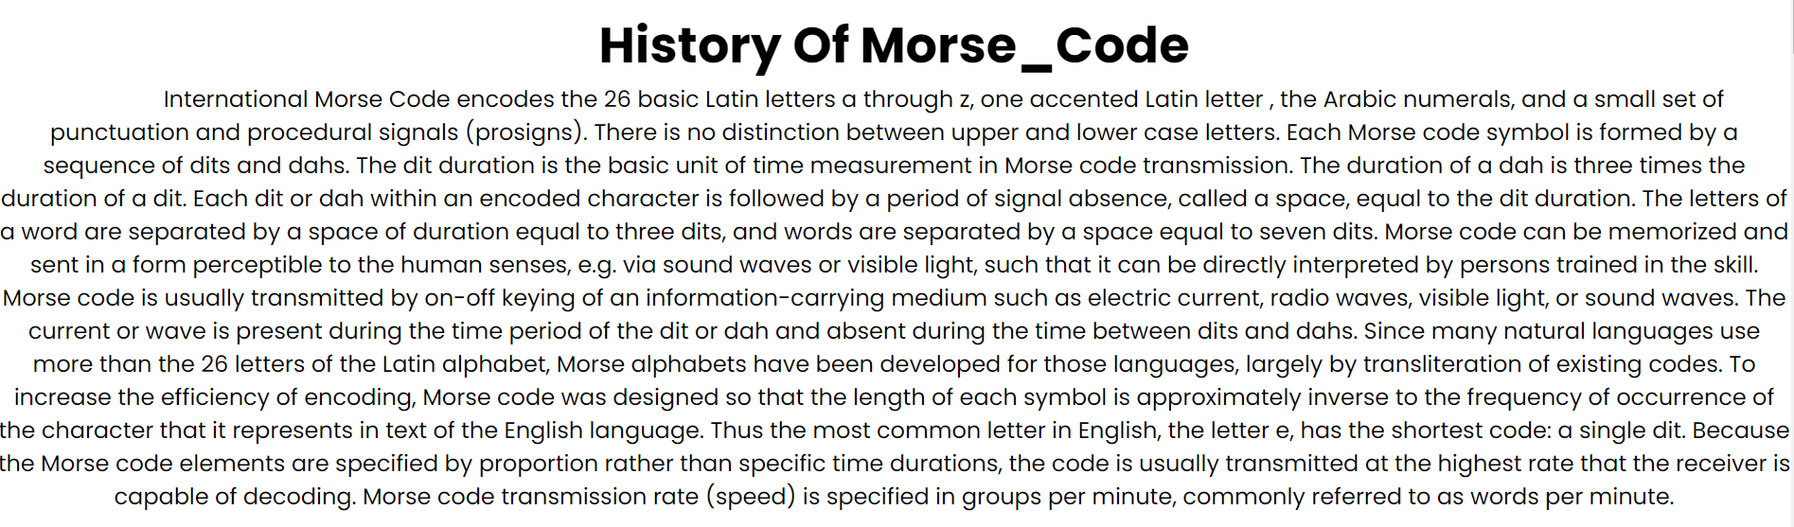 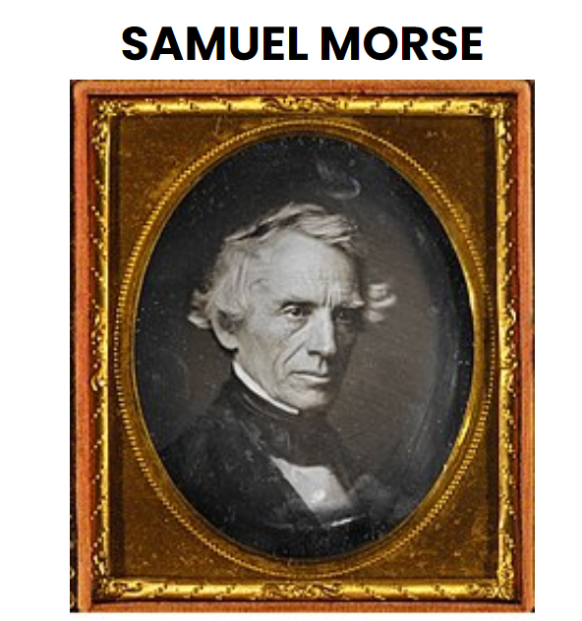 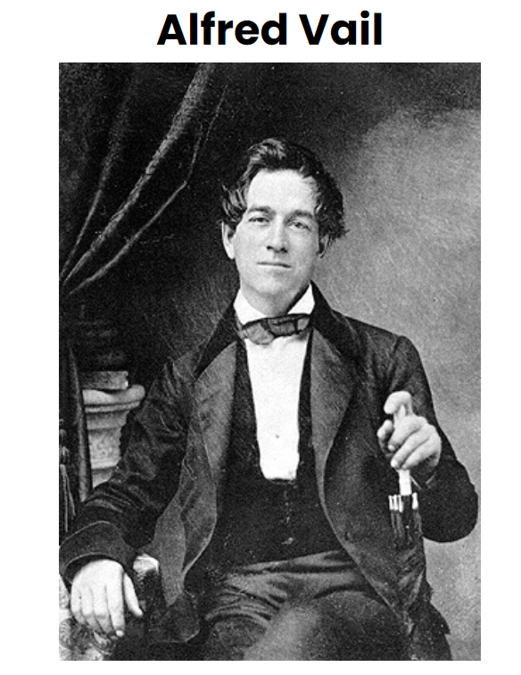 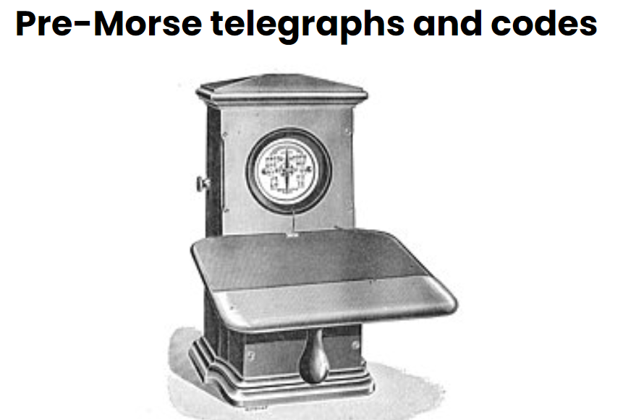 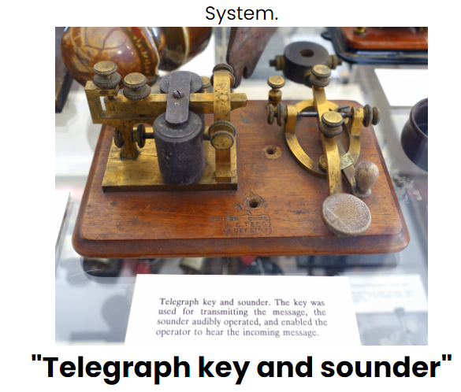



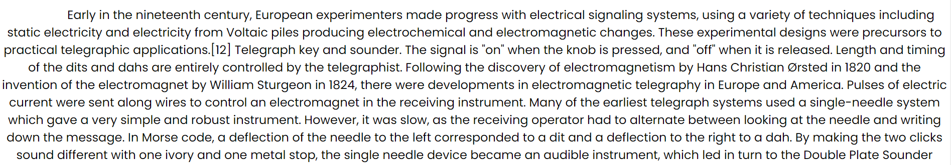

# CONCLUSION :

In the original Morse code version, the separation of key down is done by (key up) from the next letter that was a dot (or, as it sounded as a telegrapher, a “dit”) and the key down quickly twice in succession was a dash(a “dah” or “dit-dit”). Representation of each characters is done by a dot, dash, or some combination to know about the sound system perfectly. There are various stories concerning about how the Morse code was originally developed. According to one account, The person who have developed the Morse code i.e., Samuel Morse went to a printer’s shop and counted the amount of printer type the printer had for each letter of the alphabet for his understanding and scripting it with Morse code. Samuel Morse then interpreted these counts as approximations of the relative frequency of each of the letters are in typical English text. He organized the Morse code so that the shortest symbols were associated with the most frequent characters as per their condition. Thus, for example, A and T, the most often-used letters in the English language, were represented by a single dot and single dash, respectively. The least frequently occurring letters, such as J and Y, and numerals and punctuation marks were given more complex and longer representations. And there were No differentiation was made for uppercase and lowercase. Morse code offers a slow but reliable means of transmitting and receiving wireless text messages through conditisons involving noise, fading, or interference. This is primarily because its simple binary code (key down or key up) allows for an extremely narrow bandwidth. Even the brain and ear of the human make a remarkable digital receiving devices. In Nowadays onwards, Morse code is used till a limited extent by military and amateur radio operators and landline telegraphers.

# FUTURE ENHANCEMENTS

Following are the few features which can be adapted within the application for better enhancement.

* Make an ERP in this website.
* Make an online payment gateway.
* Providing study material in a website.